**Dragon Quiz**

What is your favorite dragon from the movie *How to Train your Dragon*? If you can’t decide then take this quiz to see which dragon. Add up your points and you will find out the dragon you got.

**What ability do you want your dragon to have?**

1. Fire Breath
2. Unrivaled Strength
3. Extreme Speed
4. Stunning Gas
5. Venomous spines

**One word to describe yourself.**

1. Courageous
2. Loyal
3. Inventive
4. Ambitious
5. Brave

**What is your favorite color?**

1. Red
2. Green
3. Purple
4. Yellow
5. Blue

**What is your dream job?**

1. Carpenter
2. Teacher
3. Policeman
4. Firefighter
5. Computer Programer

**What size would you prefer?**

1. Extra Large
2. Extra Small
3. Small
4. Large
5. Medium

**What is your favorite time of day?**

1. Dusk
2. Morning
3. Night
4. Afternoon
5. Dawn

**What do you look for in a friend?**

1. Loyalty
2. Common Interests
3. Intelligence
4. Humor
5. Beauty

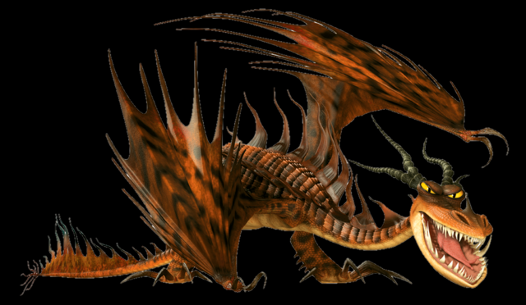Monstrous Nightmare = 7-12

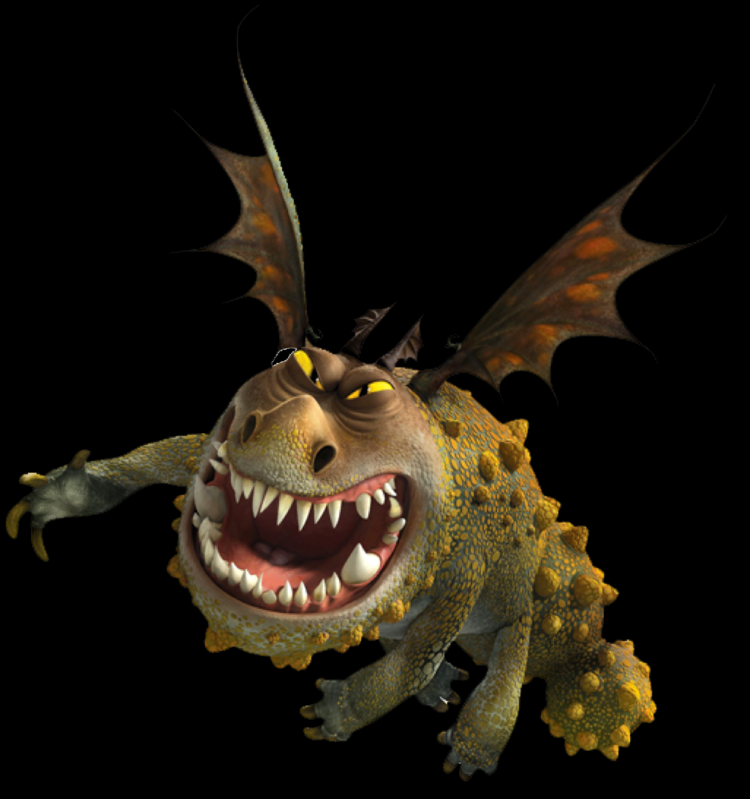Gronckle = 12-14

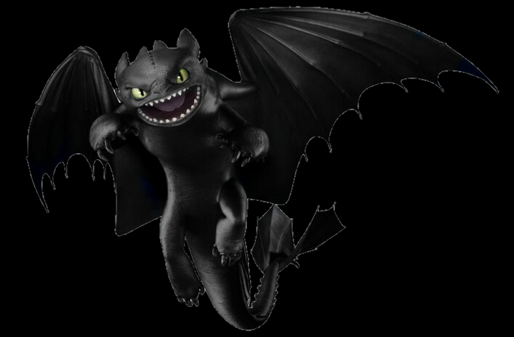Night Fury = 15-21

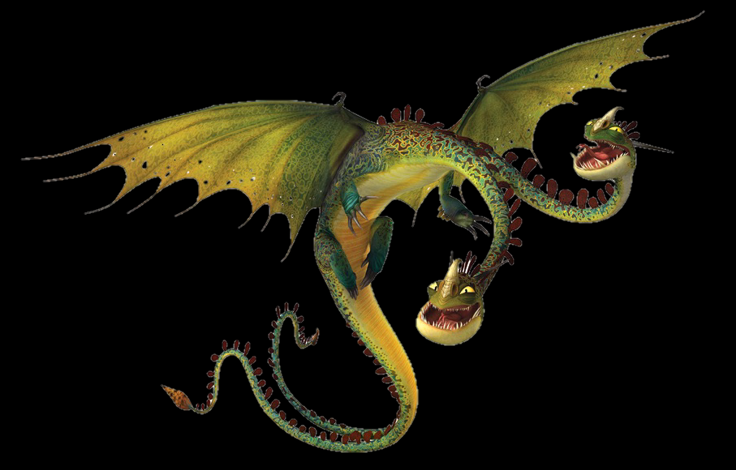Hideous Zippleback = 22-28

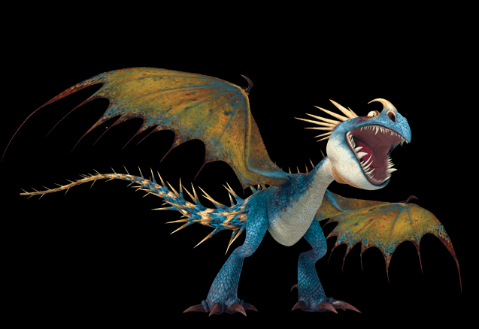Deadly Nadder = 29-35